John Michael Go
Career Entry Level Java Programming
Date: Jan. 16, 2013

DAY 4

Program Name: Arithmetic

Objective: Program computes for different mathematical/arithmetic operators.

Algorithm:

- Program computes for different mathematical/arithmetic operators.

Flowchart:

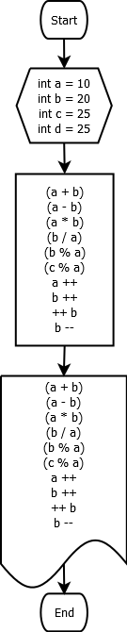

Pseudocode:

public class Arithmetic {

public static void main(String[] args) {

int a = 10;
int b = 20;
int c = 25;
int d = 25;

System.out.println("Math/Arithmetic Operators");
System.out.println("1. a + b = " + (a + b));
System.out.println("2. a - b = " + (a - b));
System.out.println("3. a * b = " + (a * b));
System.out.println("4. b / a = " + (b / a));
System.out.println("5. b mod a = " + (b % a));
System.out.println("6. c mod a = " + (c % a));
System.out.println("7. a++ = " + a++);
System.out.println("8. b++ = " + b++);
System.out.println("9. ++b = " + ++b);
System.out.println("10. b-- = " + b--);

}

}

Screenshot:

